DAYANANDA SAGAR UNIVERSITY
Department of Computer Science and Engineering

MINI PROJECT REPORT
ON
REAL-TIME EMERGENCY TASK SCHEDULER
Submitted in partial fulfillment of the requirements for the
Operating Systems Mini Project

STUDENT DETAILS | FACULTY DETAILS
1. Priyanka K S – ENG24CS0168 | Project Guide:
2. Pallavi U – ENG24CS0156 | Academic Year: [2026–2027]
3. Purvi Srinivasa – ENG24CS0171 | Semester: [V / 5th Semester]
4. Prajna P Naik – ENG24CS0160 | Group Number: 5

DAYANANDA SAGAR UNIVERSITY
BENGALURU, KARNATAKA

CERTIFICATE
This is to certify that the mini project entitled “REAL-TIME EMERGENCY TASK SCHEDULER” is a
bona fide work carried out by the students listed below, under the guidance and supervision of [Faculty Guide Name], in partial fulfillment of the requirements for the Operating Systems course during the academic year [2026–2027].
Sl. No. | Student Name | USN | Signature
1 | Priyanka K S | ENG24CS0168
2 | Pallavi U | ENG24CS0156
3 | Purvi Srinivasa | ENG24CS0171
4 | Prajna P Naik | ENG24CS0160

Project Guide: ____________________ Head of Department: ____________________
Date: ____________________ Place: Bengaluru

ABSTRACT
The Real-Time Emergency Task Scheduler is a software-based simulation that demonstrates how an operating system can schedule multiple time-sensitive tasks on a single CPU. The application allows a user to create emergency-related tasks by specifying a task name, arrival time, execution time (CPU burst), deadline and priority. It then simulates two scheduling strategies: preemptive Earliest Deadline First (EDF) and preemptive Priority Scheduling.
The scheduler selects an eligible task at each time unit. EDF selects the ready task with the earliest deadline, whereas Priority Scheduling selects the ready task with the highest priority, where a smaller priority number represents a higher priority. The application presents the execution sequence as a Gantt-style timeline and calculates waiting time, turnaround time, response time, CPU utilization and missed deadlines. It also compares the two algorithms using a summary table and a performance graph.
The project is intended for learning and demonstration. It does not control real emergency infrastructure or replace a production operating-system scheduler. Its purpose is to help students understand CPU scheduling, preemption, ready queues, deadlines and performance evaluation through an interactive interface.
Keywords: Operating Systems, CPU Scheduling, Real-Time Systems, Earliest Deadline First, Priority Scheduling, Preemption, CPU Utilization.

TABLE OF CONTENTS
Chapter | Title
1 | Introduction
2 | Problem Statement, Objectives and Scope
3 | Operating System Concepts
4 | System Requirements and Feasibility
5 | System Design and Architecture
6 | Algorithms and Scheduling Logic
7 | Implementation Details
8 | Testing and Validation
9 | Results and Performance Analysis
10 | Limitations and Future Enhancements
11 | Conclusion
12 | References

CHAPTER 1 – INTRODUCTION

1.1 Background
An operating system manages computer resources and coordinates the execution of processes. One of its important responsibilities is CPU scheduling, which determines which ready process or task should execute next. In real-time systems, tasks may have timing constraints in addition to requiring CPU time. A task may need to finish before a specified deadline for the system to provide a useful or correct response.
Emergency-oriented examples such as ambulance alerts, fire alarms, traffic updates and data logging help illustrate why task ordering matters. Some tasks may have an earlier deadline, while others may have a higher assigned priority. These two criteria can lead to different execution orders.

1.2 Project Overview
This project provides an interactive simulation of a single-CPU scheduler. Users can add and delete tasks, select EDF or Priority Scheduling, run a simulation and inspect the resulting execution timeline and performance measures. The application is developed in Python using Streamlit for the interface, pandas for tabular presentation and Matplotlib for plotting.

1.3 Motivation
The motivation is to make CPU scheduling concepts easier to understand through visible execution timelines and measurable results. Instead of studying scheduling algorithms only through manual calculations, users can change task attributes and observe how the scheduling decision changes.

1.4 Organization of the Report
This report explains the problem, objectives, OS concepts, requirements, architecture, algorithms, implementation, testing, results, limitations and possible future improvements.

CHAPTER 2 – PROBLEM STATEMENT, OBJECTIVES AND SCOPE

2.1 Problem Statement
When several tasks compete for a single CPU, the operating system needs a rule to decide which task should execute at a given time. In a time-sensitive environment, the choice of scheduling policy can affect waiting time, response time, completion time and deadline satisfaction. It can be difficult for learners to visualize these effects using only theoretical examples.
The problem addressed by this project is to build an interactive simulation that accepts a set of emergency-related tasks, applies two scheduling algorithms—Earliest Deadline First and Priority Scheduling—and compares their execution timelines and performance metrics.

2.2 Objectives
- Develop an interactive application for entering emergency-related CPU tasks.
- Store task attributes: ID, name, arrival time, burst time, deadline and priority.
- Validate task details before scheduling.
- Implement preemptive Earliest Deadline First scheduling.
- Implement preemptive Priority Scheduling, with priority 1 as the highest priority.
- Display the execution sequence using a Gantt-style timeline.
- Calculate average waiting time, average turnaround time, average response time, CPU utilization and missed deadlines.
- Compare the two algorithms using a table and graph.

2.3 Scope
The application simulates a single CPU and a finite set of independent tasks. Each task has one CPU burst and no I/O blocking or resource dependencies. The simulation advances in one-unit time steps and reevaluates the ready tasks at each step. The system is intended for academic demonstration and does not connect to sensors, emergency services or actual operating-system kernel scheduling.

2.4 Intended Users
The intended users are students and instructors who want to learn, demonstrate or evaluate basic real-time CPU scheduling concepts.

CHAPTER 3 – OPERATING SYSTEM CONCEPTS

3.1 CPU Scheduling
CPU scheduling is the process of selecting one task from the ready tasks for execution on the CPU. The scheduling policy determines the selection rule.

3.2 Real-Time Scheduling
Real-time scheduling considers timing constraints. A task is considered to have met its deadline when its completion time is less than or equal to its deadline in this project.

3.3 Ready Queue
The ready set contains tasks that have arrived (arrival time is less than or equal to the current simulation time) and still have remaining execution time.

3.4 Preemptive Scheduling
In a preemptive scheduler, the currently running task can be interrupted so that another eligible task can execute. This project reevaluates the selected task at every one-unit time step.

3.5 Earliest Deadline First (EDF)
EDF chooses the ready unfinished task with the smallest deadline. If deadlines are equal, the implementation uses earlier arrival time and then task ID as tie-breakers.

3.6 Priority Scheduling
Priority Scheduling chooses the ready unfinished task with the smallest numeric priority value. In this application, priority 1 is the highest. Arrival time and task ID are used as tie-breakers.

3.7 CPU Burst / Execution Time
Burst time is the total amount of CPU execution required by a task. The application calls this field “Execution time” in the input form.

3.8 Waiting Time
Waiting time is the total time a task spends in the ready state rather than executing. The implementation calculates it as turnaround time minus burst time.

3.9 Turnaround Time
Turnaround time is the total elapsed time from task arrival until task completion: completion time minus arrival time.

3.10 Response Time
Response time is the time from task arrival until its first CPU execution: first start time minus arrival time.

3.11 CPU Utilization
CPU utilization is the percentage of the observed simulation interval during which the CPU is executing a task, excluding idle intervals.

3.12 Deadline Status
A task is marked MET if completion time is less than or equal to its deadline; otherwise it is marked MISSED.

CHAPTER 4 – SYSTEM REQUIREMENTS AND FEASIBILITY

4.1 Hardware Requirements
Component | Minimum / Suggested Requirement
Processor | Any modern dual-core processor or equivalent
RAM | 4 GB or more recommended
Storage | At least 100 MB free space for source code and Python packages
Display | Standard laptop or desktop display

4.2 Software Requirements
Software / Library | Purpose
Python 3 | Programming language and runtime
Streamlit | Interactive web application interface
pandas | Displaying task and metric tables
Matplotlib | Drawing scheduling timelines and comparison charts
Web browser | Accessing the locally hosted Streamlit interface
Visual Studio Code / any Python IDE | Editing and running the source code

4.3 Feasibility
Technical feasibility: The application uses widely available Python libraries and can run on a standard computer. Operational feasibility: The interface uses forms, selection controls and visual outputs, making it suitable for classroom demonstrations. Economic feasibility: The project uses Python and open-source libraries, so no paid software is required for the basic implementation.

4.4 Installation and Execution
1. Install Python 3.
2. Open a terminal in the project directory.
3. Install dependencies:
pip install streamlit pandas matplotlib
4. Run the application:
streamlit run app.py
5. Open the local URL displayed by Streamlit in a web browser.
The submitted requirements.txt file in the supplied ZIP was empty at the time of inspection. Before final submission, add the required package names (streamlit, pandas and matplotlib) so that the environment can be reproduced using pip install -r requirements.txt.

CHAPTER 5 – SYSTEM DESIGN AND ARCHITECTURE

5.1 Architecture Overview
The application follows a modular design. The user interacts with app.py. Task creation and validation are handled by task_manager.py. Scheduling decisions are handled by scheduler.py. Performance measures are calculated by metrics.py. The main application coordinates these modules and displays the results.
Module | Main Responsibility
app.py | Streamlit interface, session task list, algorithm selection, simulation execution and result display
task_manager.py | Create tasks, validate fields, generate the next task ID and provide sample tasks
scheduler.py | Implement EDF and preemptive Priority Scheduling and generate execution intervals
metrics.py | Calculate per-task metrics, overall averages, CPU utilization and missed deadlines
requirements.txt | List Python package dependencies (must be completed before submission)
README.md | Project overview and setup instructions (must be completed before submission)

5.2 Processing Workflow
Step | Description
1. Input | User enters task name, arrival time, execution time, deadline and priority.
2. Validation | Task Manager checks required fields, IDs, numeric values and valid ranges.
3. Selection | User chooses EDF or Priority Scheduling.
4. Scheduling | Scheduler repeatedly selects an arrived, unfinished task or records CPU idle time.
5. Metrics | Metrics module calculates completion, turnaround, response, waiting and deadline status.
6. Display | Streamlit shows the timeline, task results, summary metrics and comparison.

5.3 Data Structure
Each task is represented as a Python dictionary with the following fields:
{"id": "P1", "name": "Data Logging", "arrival": 0,
"burst": 6, "deadline": 15, "priority": 4}
Field | Meaning | Example
id | Unique task identifier | P1
name | Task description | Data Logging
arrival | Time at which the task becomes ready | 0
burst | Total required CPU execution time | 6
deadline | Latest desired completion time | 15
priority | Scheduling priority; 1 is highest | 4

5.4 Assumptions
- The simulation models one CPU.
- All tasks are independent and require one CPU burst.
- Time is represented using integer units.
- The scheduler reselects a task at every one-unit boundary.
- Context-switch overhead is assumed to be zero.
- Tasks do not block for I/O during execution.
- All tasks are eventually executed; deadline misses are reported rather than used to stop execution.

CHAPTER 6 – ALGORITHMS AND SCHEDULING LOGIC

6.1 Earliest Deadline First (EDF)
EDF is a dynamic scheduling policy. At each scheduling decision, the ready task with the earliest (smallest) deadline is selected. A newly arrived task with an earlier deadline can preempt the currently executing task at the next one-unit scheduling boundary.
Algorithm:
- Initialize each task’s remaining execution time to its burst time.
- Set simulation time to zero and create an empty timeline.
- Find tasks whose arrival time is not greater than the current time and whose remaining time is positive.
- If no task is ready, record an IDLE interval; otherwise select the ready task with the earliest deadline.
- Execute the selected task for one time unit and reduce its remaining time by one.
- Merge adjacent timeline intervals belonging to the same task.
- Advance time by one and repeat until all tasks finish.

6.2 Priority Scheduling
The project implements preemptive Priority Scheduling. The ready task with the smallest numeric priority is selected. Priority 1 is treated as the highest priority. If a task with a higher priority arrives, it can preempt the current task at the next scheduling boundary.
- Initialize remaining execution time for every task.
- At the current time, identify arrived tasks that are not yet complete.
- If the ready set is empty, record CPU idle time.
- Otherwise, select the task with the smallest priority number.
- Execute for one time unit, update remaining time and record the interval.
- Advance the simulation clock and repeat until every task is complete.

6.3 Metric Formulas
Metric | Formula used
Completion Time (CT) | End time of the task’s final execution interval
Turnaround Time (TAT) | CT − Arrival Time
Response Time (RT) | First CPU Start Time − Arrival Time
Waiting Time (WT) | TAT − Burst Time
CPU Utilization | (Total Busy CPU Time ÷ Total Observed Time) × 100
Missed Deadline | MISSED if CT > Deadline; otherwise MET

Average waiting, turnaround and response times are calculated by summing the corresponding task values and dividing by the number of tasks. CPU busy time is the sum of all non-IDLE execution intervals. The observed interval extends from the first timeline start to the final timeline end.

CHAPTER 7 – IMPLEMENTATION DETAILS

7.1 User Interface (app.py)
The main file configures the Streamlit page and displays the project title and description. A sidebar form accepts task name, arrival time, execution time, deadline and priority. The initial task list is stored in Streamlit session state. The user can add a valid task, select and delete a task, choose a scheduling algorithm and run the simulation.
After scheduling, the application draws a horizontal bar timeline. It displays the selected algorithm’s performance summary and individual task results. It also calculates both EDF and Priority Scheduling results on the same task list and presents a comparison table and bar chart.

7.2 Task Management (task_manager.py)
The create_task() function returns a dictionary containing all task attributes. The validate_tasks() function checks that the list is not empty, each task is a dictionary, required fields exist, task IDs are non-empty and unique, names are not blank, numeric fields are integers, arrival time is non-negative, burst time is positive, deadline is later than arrival and priority is at least 1. generate_next_task_id() selects the first available ID in the P1, P2, P3 sequence.

7.3 Scheduling Engine (scheduler.py)
The schedule_edf() and schedule_priority() functions maintain a remaining-time dictionary. Each loop identifies ready unfinished tasks, chooses a task according to the selected policy, executes it for one time unit and records the interval. When no task is ready, the timeline records IDLE. Consecutive intervals for the same task are merged to make the timeline easier to read.

7.4 Performance Evaluation (metrics.py)
The calculate_metrics() function scans the timeline to determine each task’s first start time and completion time. It then calculates turnaround, response and waiting times and checks deadline status. Finally, it computes CPU utilization and the average metrics. The function returns task-level results and an overall summary.

7.5 Interface Output
- Emergency Task List – displays task ID, name, arrival, burst, deadline and priority.
- Scheduling Timeline – visual representation of CPU execution and idle periods.
- Performance Summary – average waiting, turnaround and response times, CPU utilization and missed deadlines.
- Individual Task Results – completion time and task-level performance values.
- EDF vs Priority Comparison – tabular and graphical comparison of both algorithms.

CHAPTER 8 – TESTING AND VALIDATION

8.1 Testing Approach
The project should be tested at the task-validation level, algorithm level, metrics level and end-to-end interface level. The following cases are suitable for the submitted implementation. Execute them on the final version and mark the actual result and status based on the observed run before submission.
Test ID | Test Input / Action | Expected Result | Observed Result to Record
TC01 | Valid task details | Task is accepted and added to the list | Task added
TC02 | Empty task list | Validation rejects an empty list | Please add at least one task.
TC03 | Blank task name | Validation rejects the task | Task name cannot be empty
TC04 | Duplicate task ID | Validation rejects duplicate ID | Duplicate task ID reported
TC05 | Negative arrival time | Validation rejects the task | Arrival cannot be negative
TC06 | Zero / negative burst | Validation rejects the task | Burst must be positive
TC07 | Deadline not later than arrival | Validation rejects the task | Deadline must be later than arrival
TC08 | Priority less than 1 | Validation rejects the task | Priority must be at least 1
TC09 | Run EDF on valid tasks | EDF timeline and metrics are generated | Timeline and summary displayed
TC10 | Run Priority Scheduling | Priority timeline and metrics are generated | Timeline and summary displayed
TC11 | Task arrives after time zero | CPU idle interval is recorded until arrival | IDLE interval visible
TC12 | Task completes after deadline | Task is marked MISSED | Missed deadline count increases

8.2 Sample Scheduling Dataset
Task ID | Task Name | Arrival | Burst | Deadline | Priority
P1 | Data Logging | 0 | 6 | 15 | 4
P2 | Ambulance Alert | 2 | 2 | 5 | 1
P3 | Traffic Update | 20 | 2 | 30 | 3
P4 | Fire Alarm | 20 | 1 | 30 | 2

8.3 Sample EDF Execution
For the sample dataset above, EDF executes Data Logging from 0–2, Ambulance Alert from 2–4, Data Logging from 4–8, the CPU remains idle from 8–20, Traffic Update executes from 20–22 and Fire Alarm executes from 22–23.

8.4 Sample Priority Execution
For the same dataset, Priority Scheduling executes Data Logging from 0–2, Ambulance Alert from 2–4, Data Logging from 4–8, the CPU remains idle from 8–20, Fire Alarm executes from 20–21 and Traffic Update executes from 21–23.

8.5 Validation Notes
The source code validates task attributes before scheduling. The interface uses the same validation function when a task is added and again before running the simulation. A separate test script or manual test record should be included in the final submission to show the actual outcomes.

CHAPTER 9 – RESULTS AND PERFORMANCE ANALYSIS

9.1 Observed Performance Results
The following values are taken from the supplied application screenshots for the sample task set. They should be retained only if the final application run reproduces the same input values and results.
Performance Metric | EDF | Priority Scheduling
Average Waiting Time | 1.00 | 0.75
Average Turnaround Time | 3.75 | 3.50
Average Response Time | 0.50 | 0.25
CPU Utilization | 47.83% | 47.83%
Missed Deadlines | 0 | 0

9.2 Task-Level Results – EDF
Task | Completion | Turnaround | Response | Waiting | Deadline Status
P1 – Data Logging | 8 | 8 | 0 | 2 | MET
P2 – Ambulance Alert | 4 | 2 | 0 | 0 | MET
P3 – Traffic Update | 22 | 2 | 0 | 0 | MET
P4 – Fire Alarm | 23 | 3 | 2 | 2 | MET

9.3 Task-Level Results – Priority Scheduling
Task | Completion | Turnaround | Response | Waiting | Deadline Status
P1 – Data Logging | 8 | 8 | 0 | 2 | MET
P2 – Ambulance Alert | 4 | 2 | 0 | 0 | MET
P3 – Traffic Update | 23 | 3 | 1 | 1 | MET
P4 – Fire Alarm | 21 | 1 | 0 | 0 | MET

9.4 Interpretation
For the sample run, Priority Scheduling has lower average waiting time (0.75 compared with 1.00), lower average turnaround time (3.50 compared with 3.75) and lower average response time (0.25 compared with 0.50). Both algorithms have the same CPU utilization of 47.83% and both complete all four tasks before their deadlines.
The difference in task order occurs after time 20. EDF selects Traffic Update first because its deadline is 30 and its arrival time is 20; Fire Alarm also has deadline 30, and the EDF tie-breaker selects the earlier arrival first (both arrive at 20), then the task ID. Priority Scheduling selects Fire Alarm first because its priority value 2 is higher than Traffic Update’s priority value 3.
These results apply only to this particular task set. They do not establish that Priority Scheduling is always better than EDF. Different arrival times, burst times, deadlines and priorities can produce different results.

9.5 Graph Interpretation
The performance comparison graph provides a visual comparison of the average metrics and CPU utilization. The missed-deadline graph may appear blank when both algorithms have zero missed deadlines because zero-height bars are not visible. For a clearer presentation, annotate the graph with the numeric value 0 above each category or use a text summary when both values are zero.

CHAPTER 10 – LIMITATIONS AND FUTURE ENHANCEMENTS

10.1 Current Limitations
- The project is a simulation and does not modify or control the actual operating system scheduler.
- It models only one CPU.
- Time advances in integer units and scheduling decisions occur at one-unit boundaries.
- Context-switch overhead is not included.
- Tasks are assumed to be independent and do not perform I/O blocking.
- Only one CPU burst per task is modelled.
- The application does not currently model periodic task releases, resource sharing or multicore scheduling.
- The sample performance values depend on the task set entered by the user.

10.2 Future Enhancements
- Add Round Robin, First Come First Served and Shortest Remaining Time First algorithms.
- Allow users to configure context-switch overhead and time quantum where relevant.
- Add multicore CPU scheduling simulation.
- Support periodic and recurring real-time tasks.
- Add export of results to CSV or PDF.
- Add automated unit tests and a downloadable test report.
- Improve the missed-deadline chart by annotating zero values and testing deadline-miss scenarios.
- Add a feature to save and reload task sets.

CHAPTER 11 – CONCLUSION
The Real-Time Emergency Task Scheduler demonstrates the operation of two preemptive CPU scheduling policies—Earliest Deadline First and Priority Scheduling—through an interactive Python application. Users can create and manage tasks, run simulations, view Gantt-style execution timelines and compare performance metrics.
The project connects theoretical Operating Systems concepts such as CPU scheduling, ready queues, preemption, deadlines and CPU utilization with a practical visual demonstration. In the sample run provided, Priority Scheduling produced slightly lower average waiting, turnaround and response times than EDF, while both algorithms achieved the same CPU utilization and met all task deadlines. The outcome demonstrates that scheduling performance depends on the characteristics of the task set and the scheduling policy.
Overall, the project provides a useful educational simulation of real-time task scheduling. It can be extended with additional algorithms, multicore support, context-switch overhead and more comprehensive automated testing.

CHAPTER 12 – REFERENCES
- Stallings, W., Operating Systems: Internals and Design Principles, Pearson.
- Python Software Foundation, Python Documentation, https://docs.python.org/3/
- Streamlit Documentation, https://docs.streamlit.io/
- pandas Documentation, https://pandas.pydata.org/docs/
- Matplotlib Documentation, https://matplotlib.org/stable/
APPENDIX A – PROJECT SCREENSHOTS
Insert or retain the following screenshots as evidence of the implemented interface and simulation outputs. The screenshots supplied with the project are included below where available. Add the final validation and missed-deadline screenshots after capturing them from the completed application.
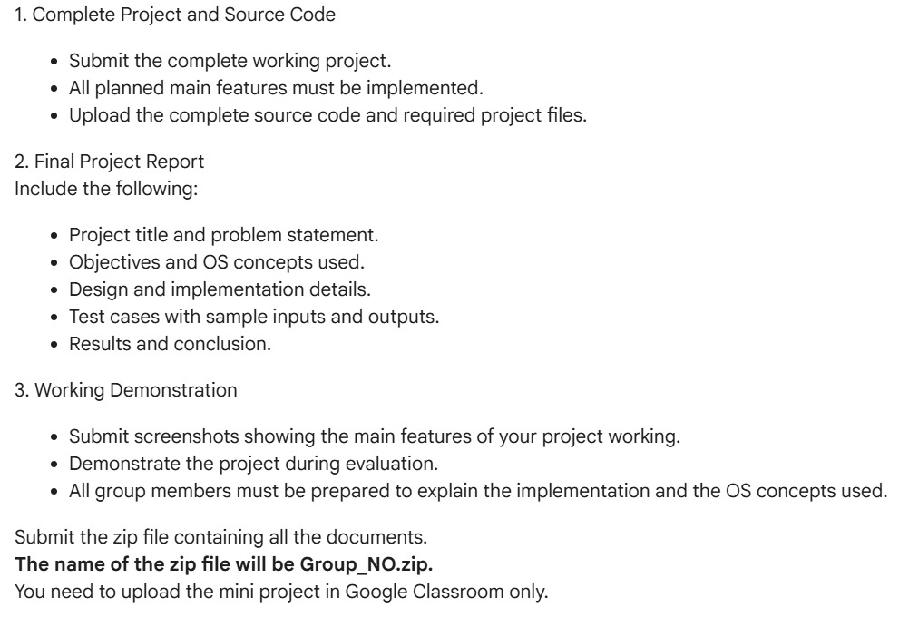
Figure A1. Project interface / scheduling output screenshot supplied with the project.
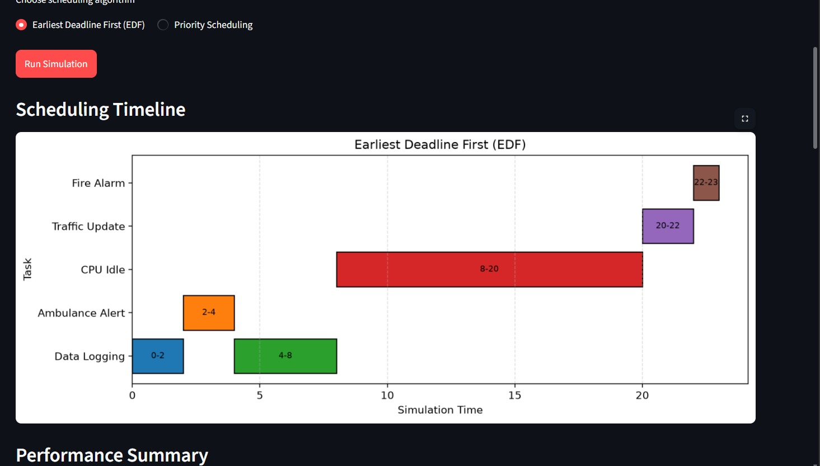
Figure A2. Project interface / scheduling output screenshot supplied with the project.
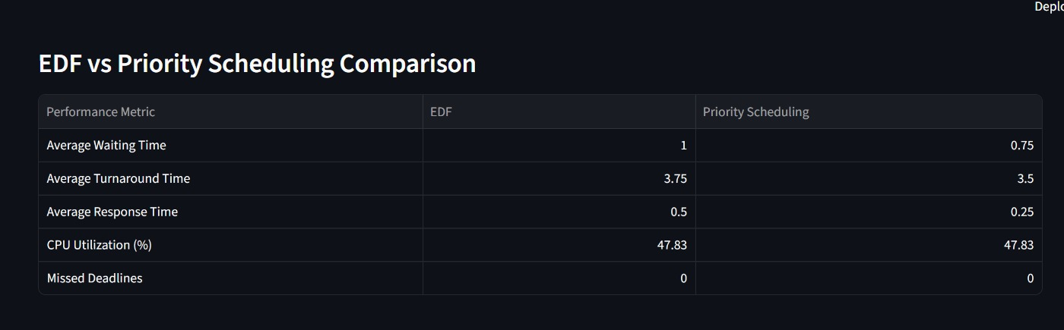
Figure A3. Project interface / scheduling output screenshot supplied with the project.
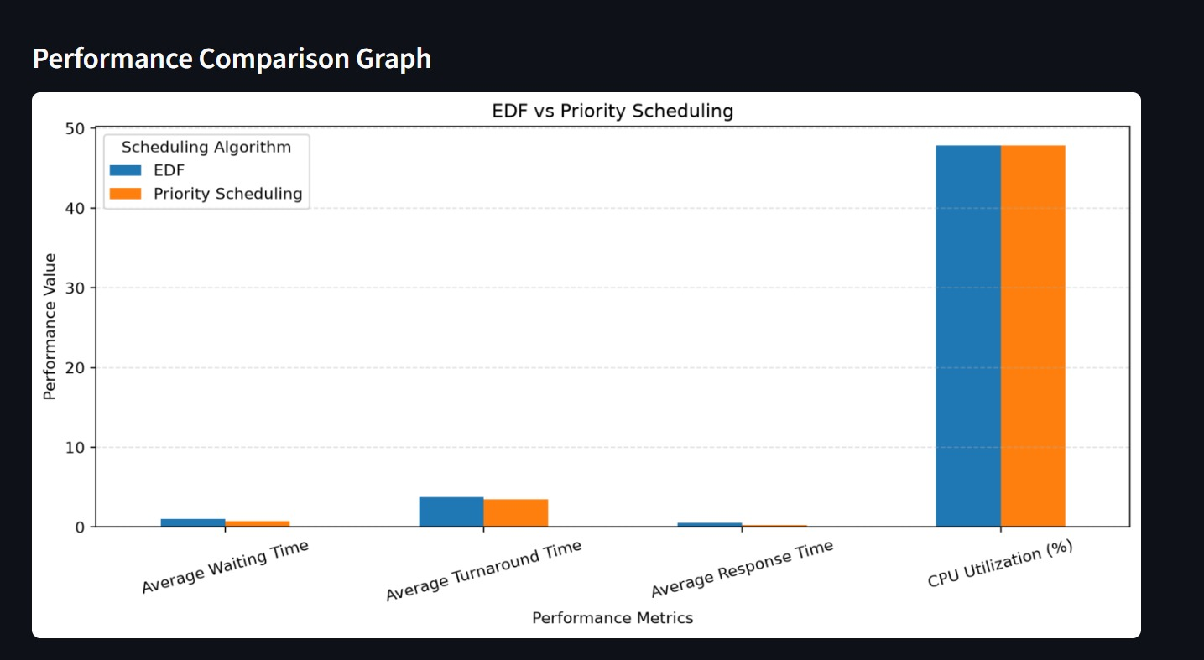
Figure A4. Project interface / scheduling output screenshot supplied with the project.
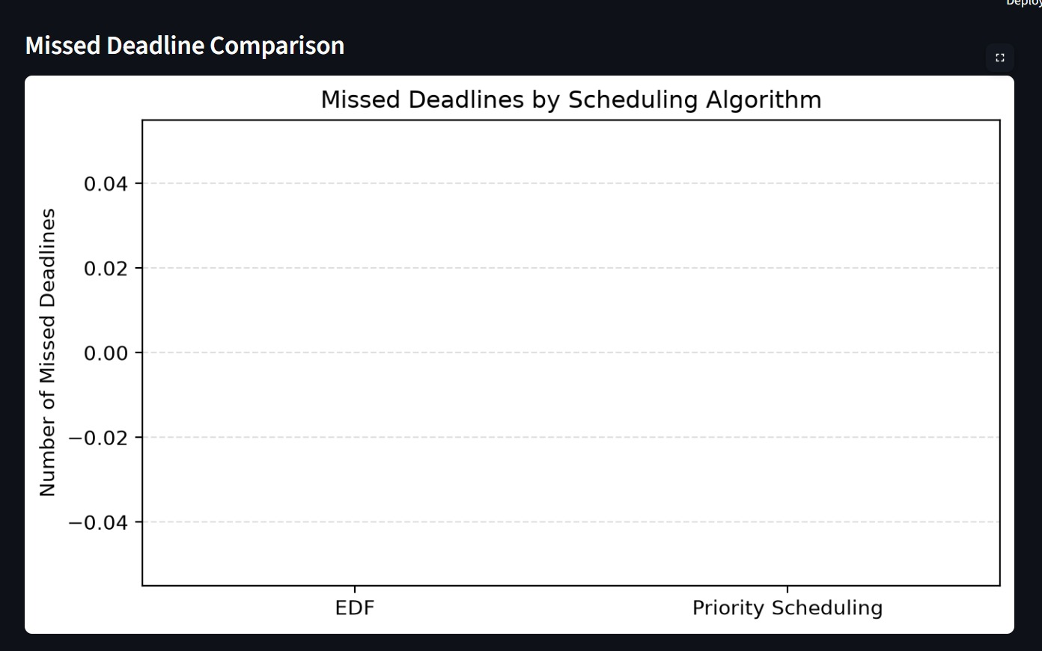
Figure A5. Project interface / scheduling output screenshot supplied with the project.
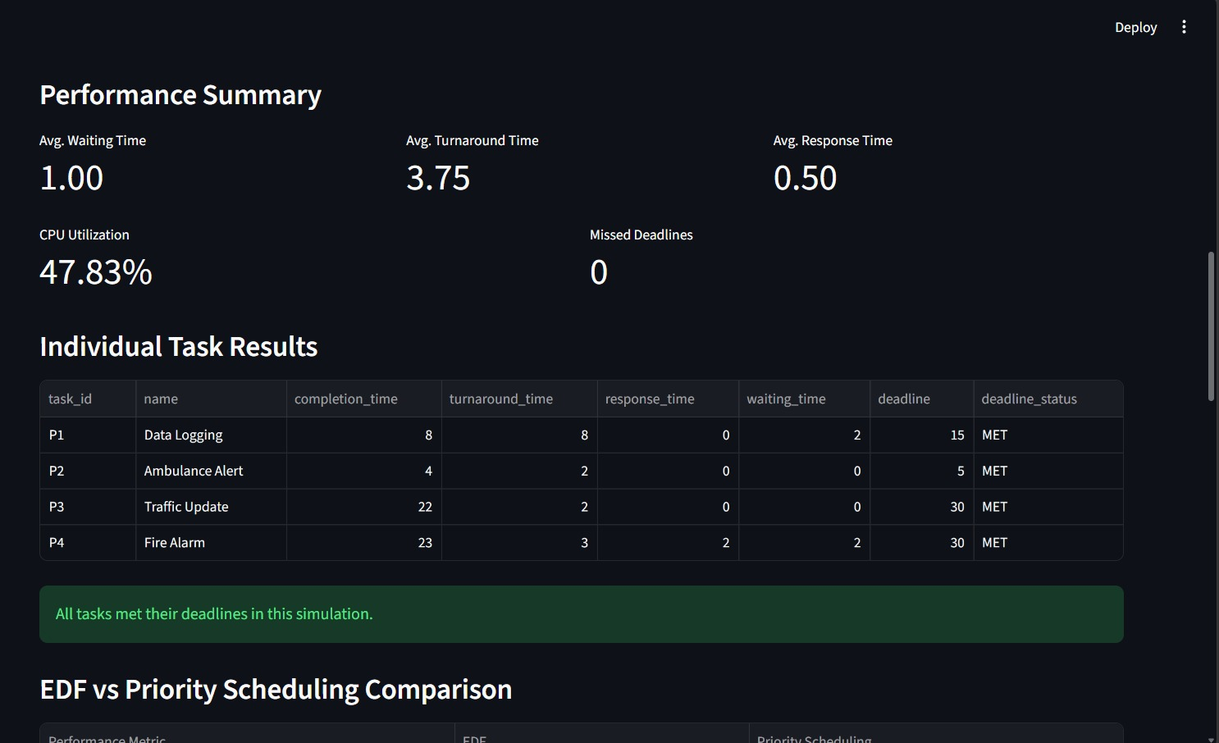
Figure A6. Project interface / scheduling output screenshot supplied with the project.
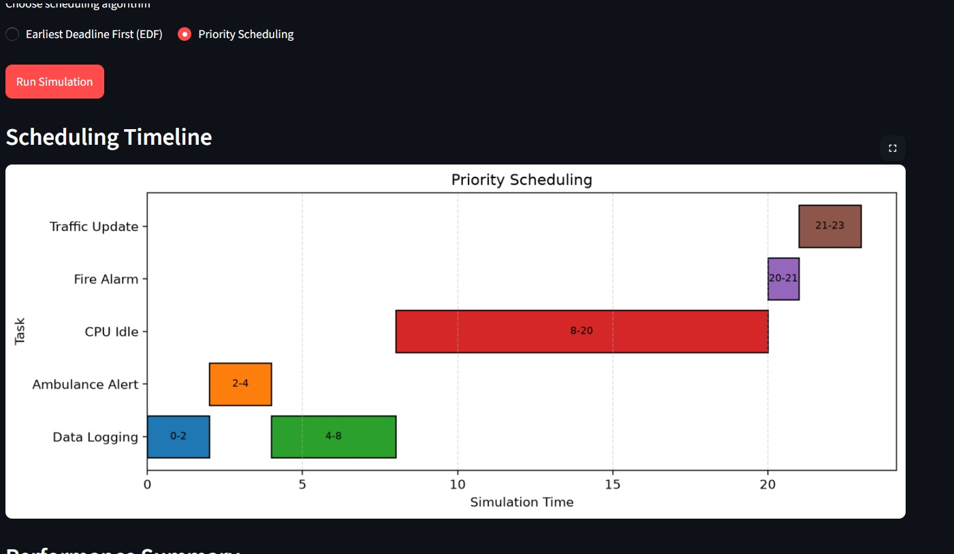
Figure A7. Project interface / scheduling output screenshot supplied with the project.
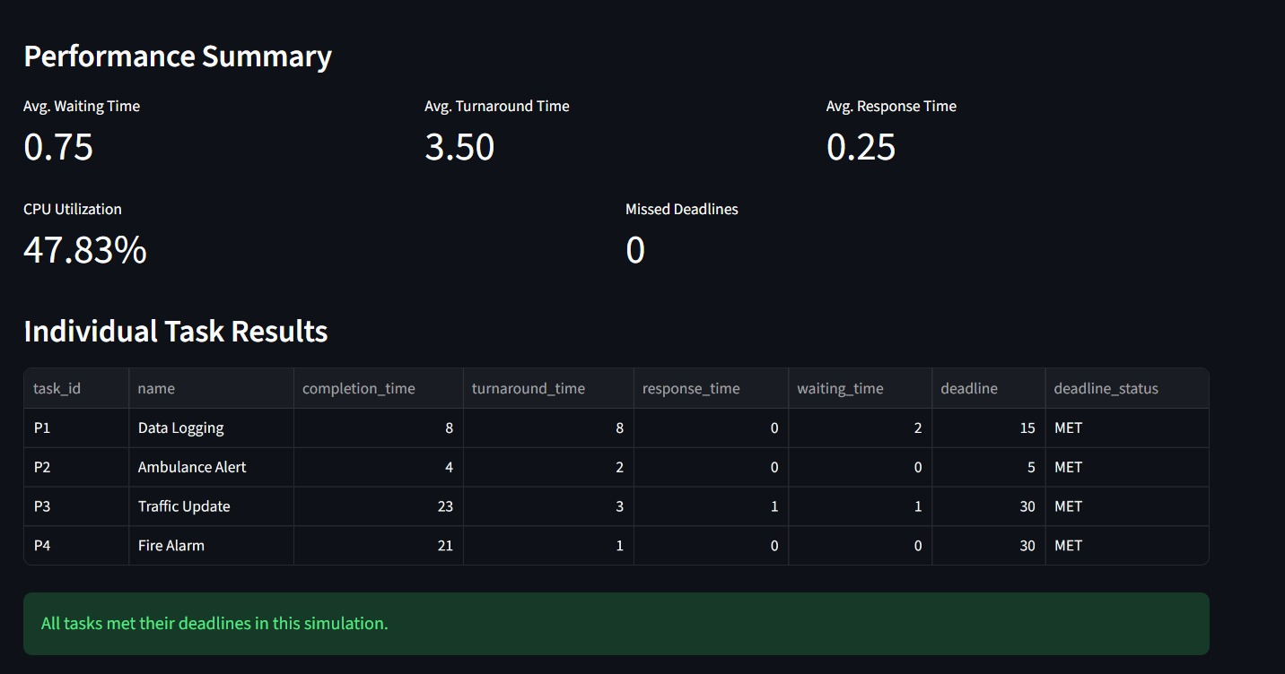
Figure A8. Project interface / scheduling output screenshot supplied with the project.
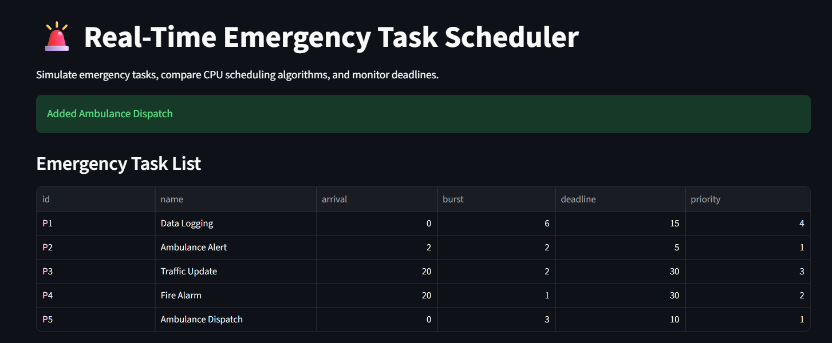
Figure A9 Adding an Emergency Task

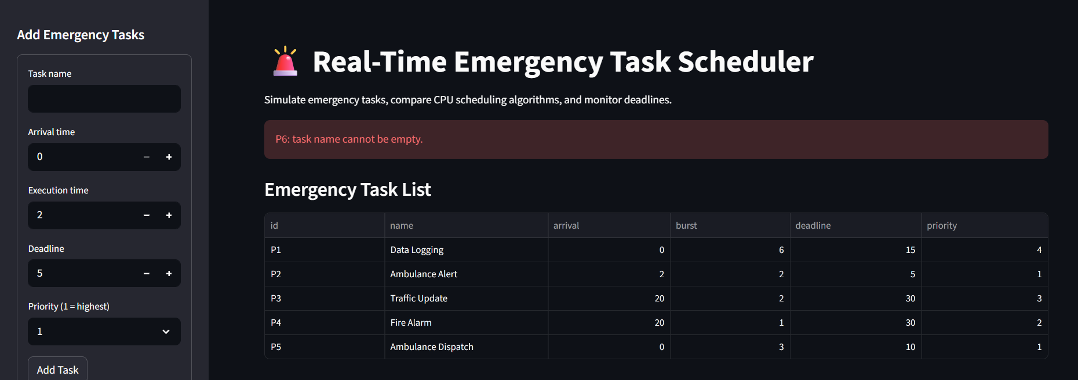
Figure A10 Input Validation Testing

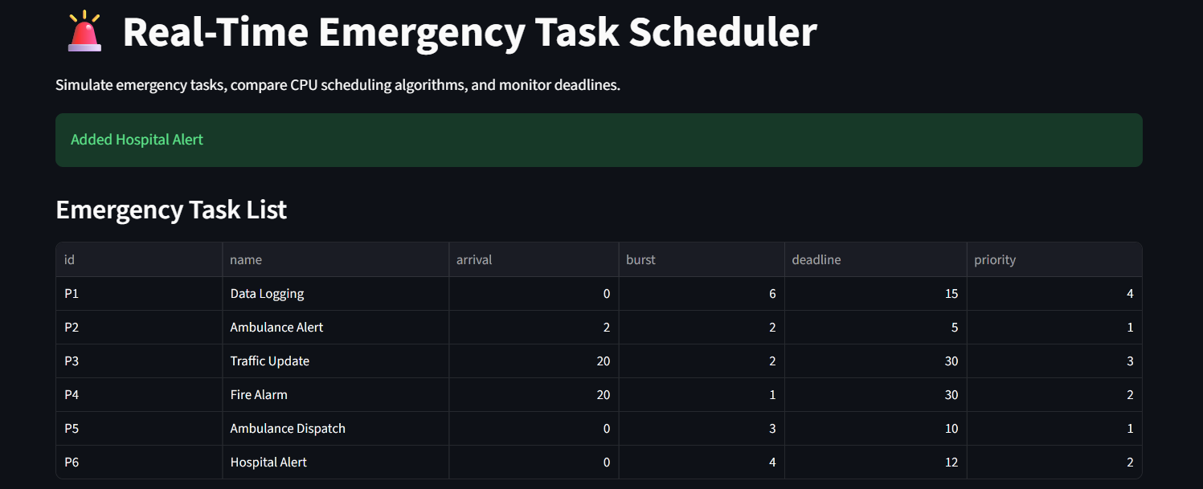 | 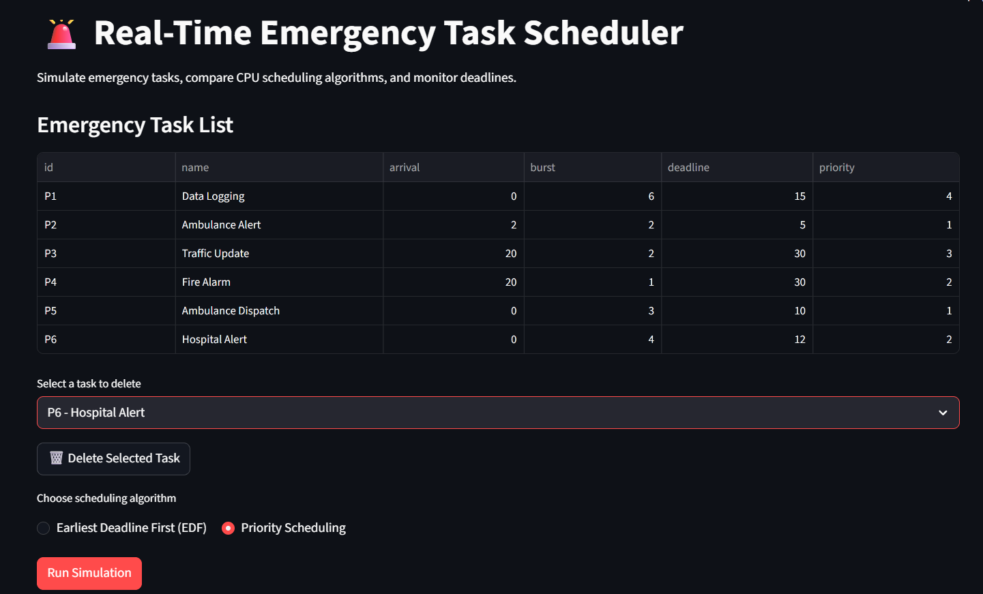
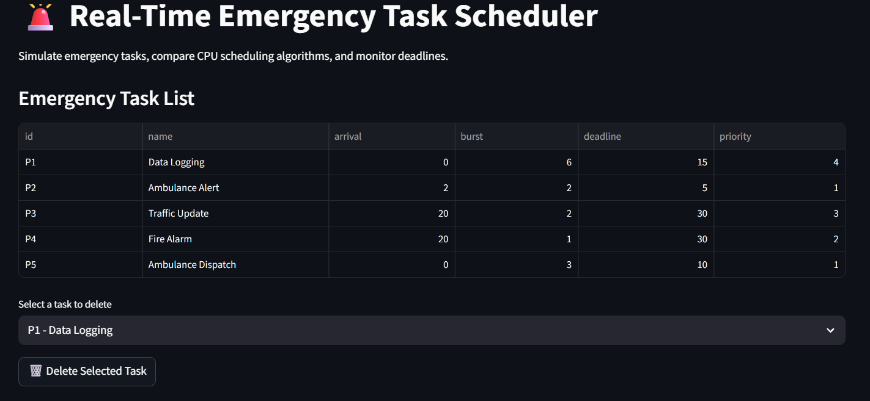
Figure A11 Task Deletion Testing

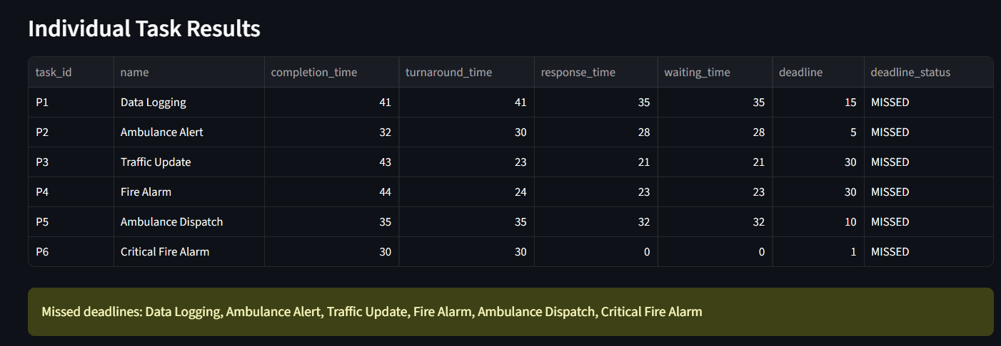
Figure A12 Missed Deadline Detection

